3. Smart Installation

3.1 Put the Smart Installation CD in your CD-ROM

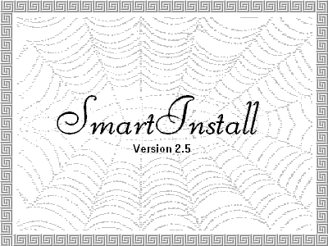

3.2 Select the language for you.
Then Select the Driver installation

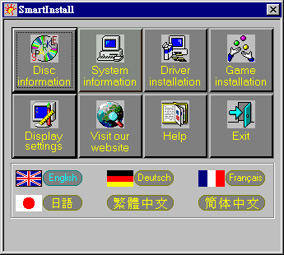

3.3 Click the Confirm Installation…button.
Then Select the OK

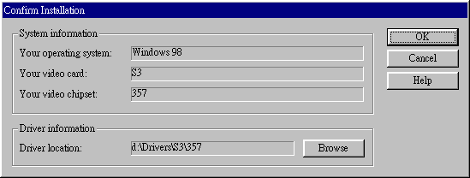

3.4 Click the Driver Confirmation
Then Select the Install

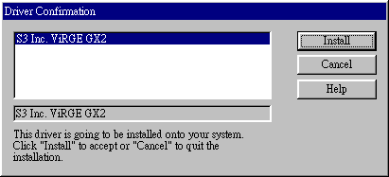

3.5 Then restart your computer.

4. Windows 95 & Windows 98 Setup

4.1 Installation and Setup

4.1.1 Windows 95
The Windows setup program installs and modifies all of the necessary files. Follow these steps to install the Windows 95 driver.
- Insert the “Window 95 Driver” Installation Diskette or DISC (CD Title Driver).
- Select Control Panel from My Computer group.

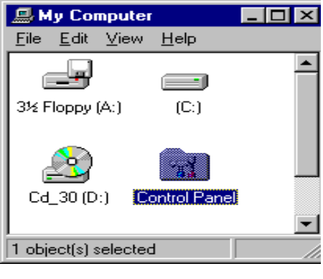

- Select the Display icon

. 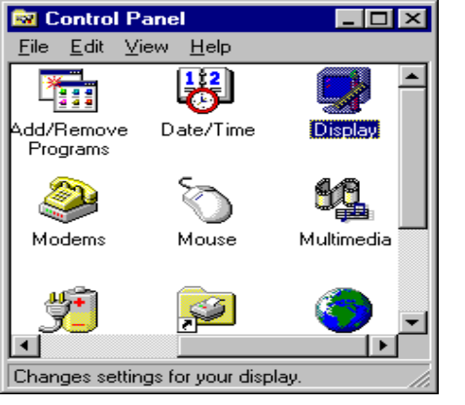

- Double-click on the Display icon in the Setting -> Control Panel folder. You can also click the right mouse button anywhere on the desktop and select the Properties option form the pop-out menu.
- Click the Settings tab.

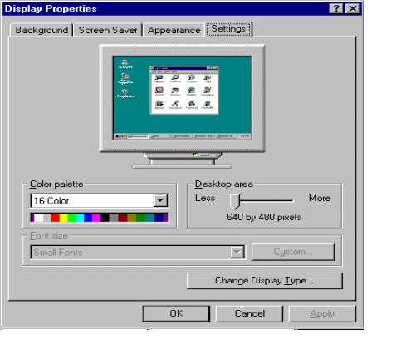
- Click the Change Display Type... button.

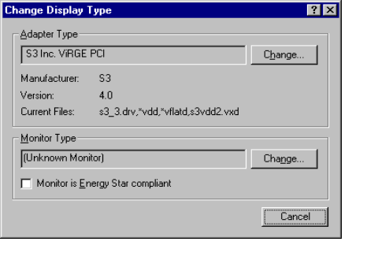

- Click the Have Disk button.

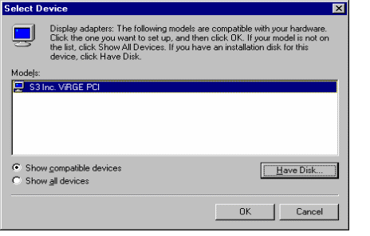
- Change directories and Select S3 ViRGE.INF.

Diskette is A: or B:\ WIN95 , Disc (CD Title) is E:\drivers\S3\357\WIN95
(“A:” or “B:”→ Diskette Drive “E:”→CD Drive “357”→VGA type)

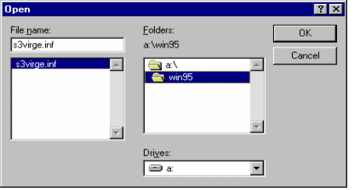
- Select S3 Trio64 V2 PCI or S3 ViRGE PCI driver form the list and click the OK button. If a message stating that one or more driver files is older than the files on the system respond YES to overwrite the files.
- Click the Close button and Apply button, and restart your computer.

4.1.2 Windows 98
- Select Control Panel from My Computer group.
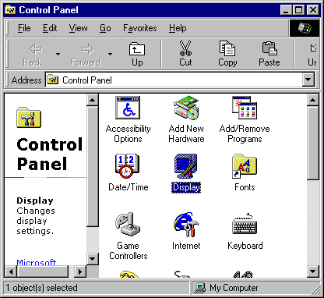
- Select the Display icon

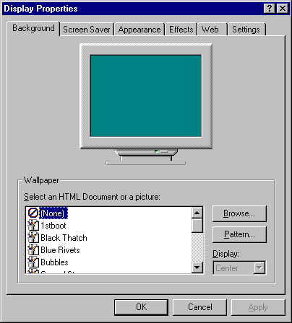

- Double-click on the Display icon in the Setting -> Control Panel folder. You can also click the right mouse button anywhere on the desktop and select the Properties option form the pop-out menu.
- Click the Settings tab.

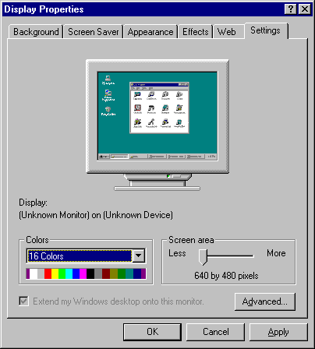

- Then show [Unknown Device.] Properties tab
Select Adapter

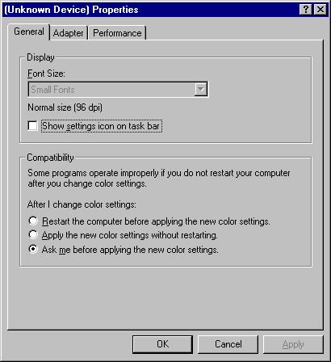

- Then show Standard PCI Graphics…. tab
Select Change

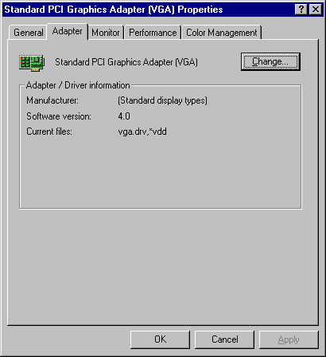

- Then show Update Device …. tab
Select Next

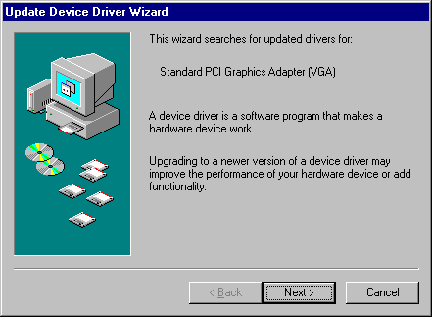

- Then show Update Device …. tab
Select Search for a better……
Then select Next.

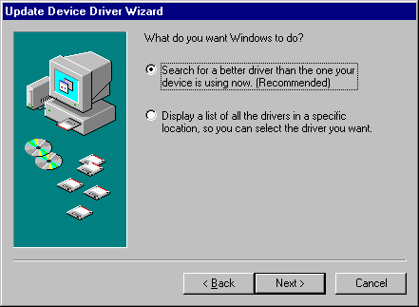

- Then show Update Device …. tab
If the Specify a location is wrong
Please select Brows

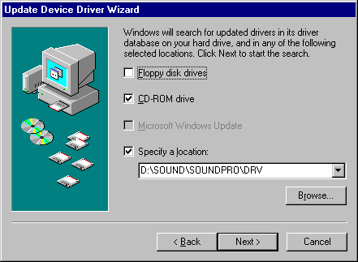

- Then show Browse for Folder tab
Select D:\Drivers\S3\260\Win98
Then select OK

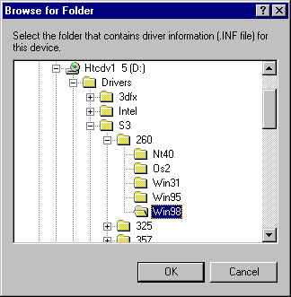

- Then show Update Device Driver Wizard tab
Select CD-ROM driver
Click the Specify a locator, if right
Then select Next

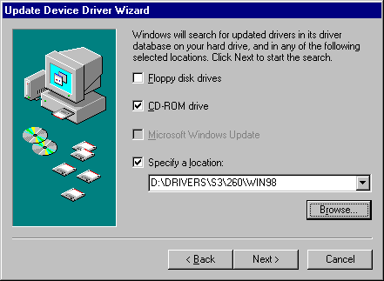

- Then show Update Device Driver Wizard tab
Select Next

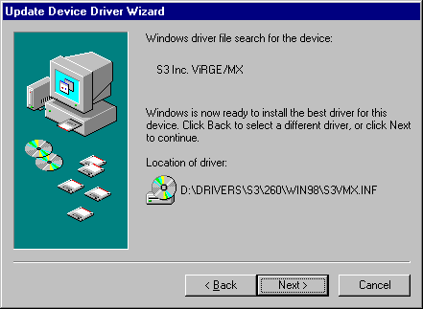

- Then show Update Device Driver Wizard tab
Select Finish

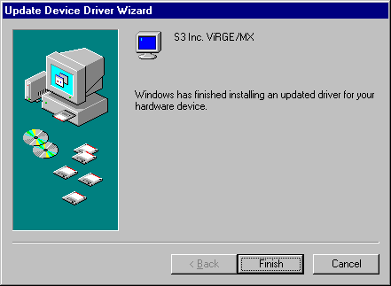

- Then show System Settings Change tab
Select OK

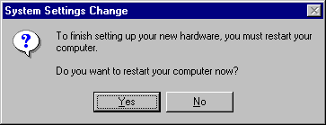

4.2 How to Change Color Depth and Resolution

- Make sure that you have installed the WINDOWS95 Driver.
- Click on the Start box in the lower left corner and proceed to Control Panel.
- Inside the Control panel group , click on Display icon to open the Display Properties folder and select the Setting table
- Click on the pull-down arrow from the Color palette area to select color depth or adjust the sliding bar to either Less or More from the Desktop area
- Select OK to restart WINDOWS95 and new color depth or the new resolution takes effect.

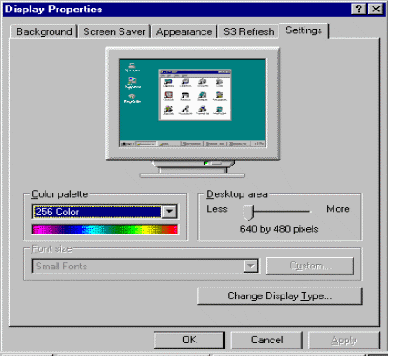

4.3 Change Refresh Rate

- Make sure that you have installed the WINDOWS95 Driver. Click on the Start box in the lower left corner and proceed to Setting, Control Panel
- Inside the Control panel group , click on Display icon to open the Display Properties folder and select the S3 Refresh table
- Click on the Change Configuration to change refresh rate
- Select OK and new refresh rate takes effect

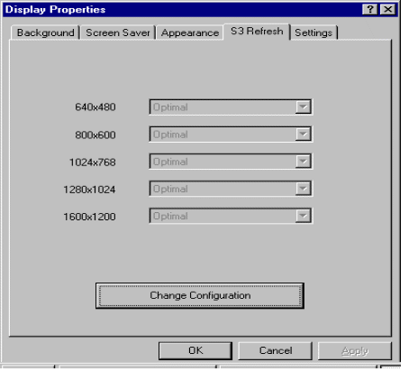
- Refresh Rate default is Optimal .
- If you change Refresh Rate from Optimal to another , you must be to restart WINDOWS 95

5. Windows NT 3.51, 4.0

The following steps describe how to install WIN NT 3.51 and 4.0 display drivers

- Select Control Panel from the Main group.
- Select the Display icon.
- Select Change Display Type.
- Select Change from the Adapter Type area.
- Select Other.
- Place the Windows NT Installation Disk or Disc (CD Title) into Driver. Click OK.
- Select Install and click “YES” when the Installing Driver dialog box appears.
- When the WINDOWS NT Setup dialog box appears select driver A or CD- ROM, and click ”Continue”.

A message appears stating that drivers were successfully installed. Click OK. Another message appears stating that the driver could not be restarted dynamically. Restart Windows NT to run the new driver. Click OK.

All brand names and trademarks are the property of their owners.

